Trade show preview of Hannover Messe from April 25 to 29, 2016
Ecodos diaphragm metering pump: Economical and safe solution for pumping fluid in the low-pressure range
In many industries, metering tasks take place in the low-pressure range of < 20 bar. Using a high-pressure pump for this purpose is usually not economical. At this year's Hannover Messe, Lewa GmbH is presenting a cutaway model of the Ecodos diaphragm metering pump, which clearly illustrates the operating principle of the low-pressure pump. The distinguishing feature is that the Ecodos diaphragm is mechanically driven,rather than hydraulically driven. Lewas pump installation demonstration stand will be another highlight of the trade show. Furthermore, the manufacturer from Leonberg is presenting an Ecosmart diaphragm metering pump with a plexiglass head, the Intellilab micro-metering pump, the odor control unit (OCU) for fully automated monitoring and control of odorizing systems, the Wilden PX8 pressure air pump and a Pomac rotary lobe pump.

The Lewa Ecodos is a robust and efficient diaphragm metering pump with mechanical diaphragm actuation that provides many options. Due to its simple construction, it operates without hydraulic oil and can also be used for sensitive applications in the pharmaceutical field. Fluids that would react with hydraulic oil can be metered just as safely. In principle, it is suitable for virtually all metering and pumping tasks in the low-pressure range. The Ecodos, as a single-drive unit with a space-saving, vertically attached motor, implements a flow rate of 0.4 to 1500 l/h per pump head and a maximum discharge pressure of 20 bar. It's multiplex capability also enables additional areas of application, for which multiple drive units with identical or different output capacities are ideally suited, particularly for low-pulsation pumping, recipe metering and mixing tasks. For areas of application that require an especially high degree of cleanliness, the Ecodos is also available in a sanitary/hygienic design with a pump head made of polypropylene or polished stainless steel. The option of controlling metering in terms of stroke length or speed results in a wide adjustment range up to 1:50. Its 13 output ratings and material options that include 1.4571, PVC, PVDF and PTFE as well as adapted accessories allow the Ecodos to be adjusted precisely to the requirements of the specific metering task in the low-pressure range.

Pump installation demonstration stand

At the Hannover Messe Booth, visitors will be able to see an installation demonstration stand, where various operating states of a diaphragm metering pump can be viewed. This includes the behavior of the pump with low suction pressure and the influence of pulsation dampers and different pipeline designs. Thanks to the plexiglass pump head used, interested parties can witness the pump process of a LEWA diaphragm metering pump and obtain valuable information about correct installation.
The Ecosmart diaphragm metering pump, a classic from Lewa, is also among the exhibits at the trade show. The hydraulically actuated metering pump offers the best price/performance ratio in its class and, thanks to its reliable operation, ensures maximum safety and minimum life cycle costs in the production process. The display items at the trade show booth also include the Intellilab micro-metering pump, which is suitable for high-precision, extremely low-volume metering up to 500 bar, the Odor Control Unit (OCU), the Pomac rotary lobe pump and the Wilden PX8, a pressure air pump for process waste, CIP chemicals and fluids with solids content and shear-sensitive products in hygienic or sterile fields.

If you would like to speak with the Lewa team or have any concrete inquiries regarding the portfolio, you can visit the Lewa team at the Hannover Messe at Booth G 43 in Hall 15.

What: Hannover Messe 2016
When: April 25-29, 2016
Where: Hanover fairground,
Hall 15, Booth G 43
Further information: www.lewa.de

LEWA GmbH was founded in 1952 as a family company by Herbert Ott and Rudolf Schestag, and today is the world's leading manufacturer of metering and process diaphragm pumps as well as complete metering systems for process technology. The company, headquartered in Leonberg, Germany, has developed over just a few decades into an international group, and its position in the world market was further strengthened by its integration into the Japanese Nikkiso Co. Ltd. in 2009. As a researching and productive company, LEWA develops technologies and works out solutions for a wide variety of its customers' applications. Products are primarily used in the oil and gas industry, in the area of gas odorization, refineries, and petrochemistry, but also in the manufacture of plastics, detergents, and cleaning agents. Additional application areas can be found in chemistry, the cosmetics industry, in pharmaceutical and biotechnology, in the food and beverage sector, and in power supply. LEWA currently has approximately 1000 employees and has 16 subsidiaries worldwide as well as representatives and sales offices in over 80 countries.

Image material:

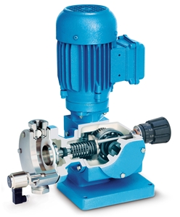
Image ID: ecodos.jpg
Caption: The Lewa Ecodos is suitable for virtually all metering and pumping tasks in the low-pressure range. Thanks to its simple design, it operates without hydraulic oil.
Source: Lewa GmbH

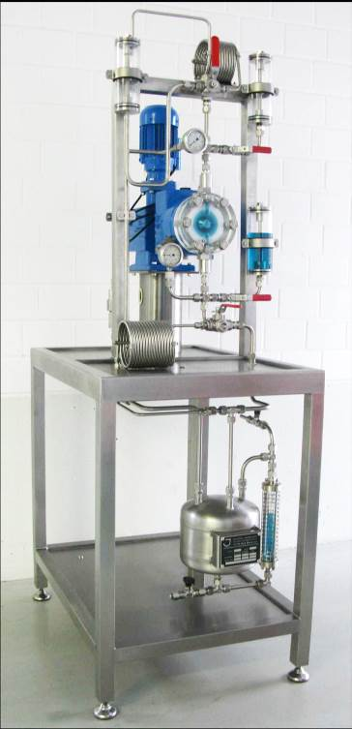
Image ID: Pumpeninstallations-Vorführstand.jpg
Caption: Pump installation demonstration stand with plexiglass pump head, to consider the pumping action of LEWA diaphragm metering pumps .
Source: Lewa GmbH

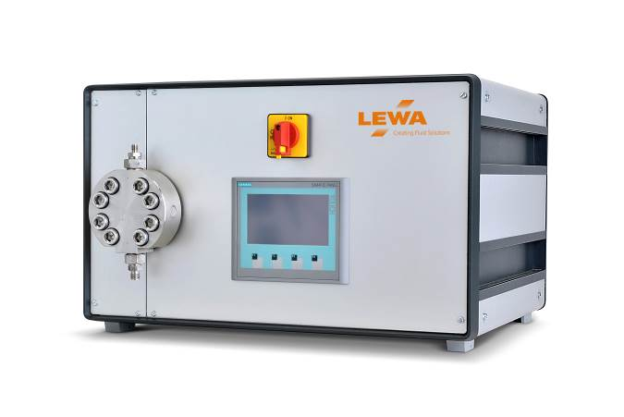
Image ID: intellilab.jpg
Caption: LEWA Intellilab for mechatronic control systems for high precision, extremely low-volume metering up to 500 bar.
Source: Lewa GmbH

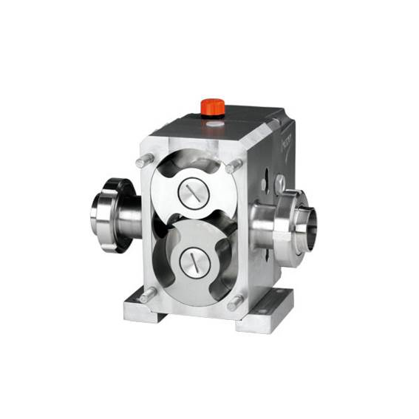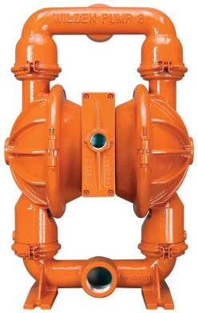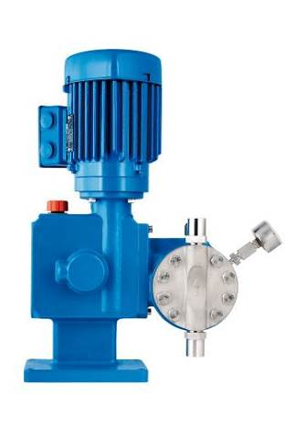
Image ID: Ecosmart.jpg, Wilden.jpg, Einsparpotential.jpg
Caption: Additional exhibits at the Hannover Messe include the Ecosmart diaphragm metering pump, the Wilden PX8 pressure air pump and a Pomac rotary lobe pump.
Source: Lewa GmbH

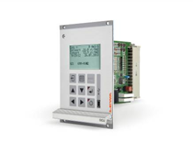
Image ID: OCU.jpg
Caption: The fully automated OCU odorizing controller continuously compares the target and actual level of odorant concentration.
Source: LEWA GmbH

More information for readers/visitors/interested parties:

LEWA GmbH
Ulmer Straße 10, 71229 Leonberg
Tel.: +49 7152 14-0, Fax: +49 7152 14-1303
E-mail: lewa@lewa.de
Internet: www.lewa.de

More information for the editors
Press agency Beatrix Gebhardt-Seele
Leonrodstraße 68, 80636 Munich
Tel.: +49 89 500315-0, Fax: +49 89 500315-15
E-mail: pressebuero@gebhardt-seele.de
Internet: www.gebhardt-seele.de

Reprints free of charge if the source is named; ask for a sample copy

