Achema trade show preview (June 11 to 15, 2018 in Frankfurt)
After G comes Z: New performance rating of 15 kW added to diaphragm metering pump series
Made versatile by its modular design and numerous pump head variants

Versatility thanks to its modular design: LEWA GmbH's Ecoflow series is suited for metering a wide range of fluids - even hazardous, toxic, abrasive, viscous or critical media. Now the German pump manufacturer has added another performance rating to its proven series: The new drive unit model, LDZ, which is designed for a hydraulic output of 15 kW, is intended to close the gap between the LDG (6 kW) and the LDH (20 kW) sizes. Just like the other models in the series, it can be used as a single or multiplex drive unit and, thanks to its modular system, can be tailored to the customer's needs. Among the five pump head types, there are also designs available for use in the food and pharmaceutical industries. During development, special attention was paid to optimizing the components with regard to the manufacturing process. The resulting cost-benefits can be passed on to the customers. At Achema 2018, LEWA will be presenting the new model in triplex design with three different pump heads. A more in-depth experience will be made possible by an augmented reality animation that gives the viewer a glance into the inside of the pump.

"The gap between our LDG and LDH Ecoflow process pump drive units is relatively large. When customers came to us looking for a pump just slightly more powerful than the LDG, we had no choice but to offer them the much more powerful—and much more expensive—LDH," explains Thomas Bökenbrink, Lead Product Manager Pumps at LEWA Leonberg. As a result sales and product management initiated the development of a new performance rating that was meant to function as an intermediate unit; the LDZ at 15 kW. The Research and Development Department called upon internal divisions such as assembly and the service and purchasing departments to make the product market-ready in the shortest amount of time possible. Various worm shaft bearing concepts were analyzed regarding service life, heat development, price, manufacturing and assembly.

The cast parts, which are subject to a complex manufacturing process, were designed with process reliability in mind. "During development, we were able to gain advantages in the design. The components have been designed in a way that is geared toward the manufacturing processes and optimized using state-of-the-art technology," Bökenbrink explains. "In the future, we want to gradually start using this optimized production process for additional drive unit models."

One pump - countless applications

"The new size allows us to be more flexible and meet different requirements," Bökenbrink adds. "This way, the customer receives the usual product quality adapted optimally to his needs." The pump is available as a single or multiplex drive unit and can be combined with other types from the Ecoflow portfolio.

With a hydraulic output of 15 kW and a flow rate of up to 18 m³/h, the new process pump can handle many applications in areas that include the chemical and the petrochemical industry as well as refineries. These industries work with corresponding media and high-pressure processes and require the machines to run reliably and precisely 24/7 all year long. In addition to process industries, the LDZ is used in the oil and gas sectors, such as for a variety of condensates or injection packages for chemicals. There are no system requirements for using the pumps in this way.

Exhibit with augmented reality function

Like most other models from the Ecoflow modules, the LDZ can be customized to individual applications. This customization means that wetted materials and process valves can be adapted specifically to the pumped fluid as needed. Furthermore, implementing a heating or cooling jacket or a remote head solution is possible at extreme temperatures. A total of five different pump head types are available. The pump can also be adapted to the food and pharmaceutical industries. Customized constructions are also available for special requests that are not yet available in the product range.

At this year's Achema trade show, LEWA will present the new model size; a multiplex pump equipped with three different pump heads. "The LDZ3 exhibit illustrates the versatile application options of our series: The remote pump head is suited for high temperatures in refineries. On the other hand, the M800, our high-pressure pump head (up to 1,000 bar) is being used to handle enormous pressures, such as those in reactor pumps. The model is completed by the M900, our pump head for a wide variety range and high flow rates," explains the product manager. The M900 design on display is the hygienic version for the food and pharmaceutical industry. In order to get a better understanding of the pump, LEWA is making an augmented reality app available on a tablet. It shows the inside of the exhibit in 3D and uses animation to simulate the functionality of the pump and various operating conditions. This way, those interested can get an insight of the functionality

Stefan Glasmeyer, CSO of LEWA, and his team will be available to talk at anytime during the Achema trade show from June 11 to 15, 2018 at booth 8.0 C62. The new performance rating will hit the market following the trade show.

What: Achema 2018
When: June 11 to 15, 2018
Where: Messe Frankfurt; Hall 8.0, Booth C62
Further information: www.lewa.com; lewa@lewa.de

LEWA GmbH was founded as a family company by Herbert Ott and Rudolf Schestag in 1952. Today it is the world's leading manufacturer of metering pumps and process diaphragm pumps as well as complete metering packages for process engineering. The Leonberg, Germany-based company developed into an international Group within a few decades and saw further improvement in its position on the world market as part of integration into the Japanese Nikkiso Co. Ltd. in 2009. As a research and production-oriented company, LEWA develops technologies and provides solutions for the vast array of applications among its customers. Its products are used mainly in the oil and gas industry, in gas odorization, in refineries and petrochemicals, as well as in the production of plastics, detergents and cleaners. Additional application areas include the chemical industry, cosmetics industry, pharmaceuticals and biotechnology, food and beverage industry, and energy utilities. LEWA currently employs around 1,200 people and owns 14 subsidiaries around the world along with having 80 representatives and sales offices in more than 80 countries.
Image material:

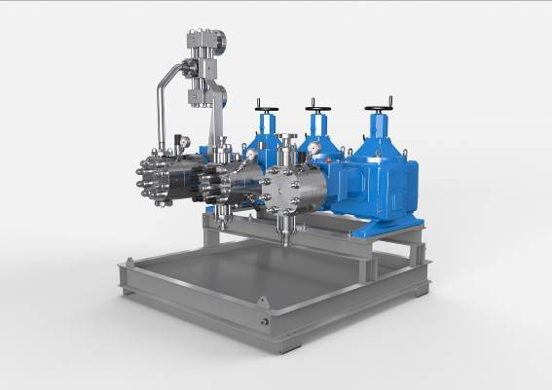
Image ID: Dosierpumpe_LDZ3.jpg
Caption: At this year's Achema trade show, LEWA will present the new model size; a multiplex pump equipped with three different pump heads. In order to get a better understanding of the pump, LEWA is making an augmented reality App available on a tablet. It shows the inside of the exhibit in 3D and uses animation to show the various operating states.
Source: LEWA GmbH

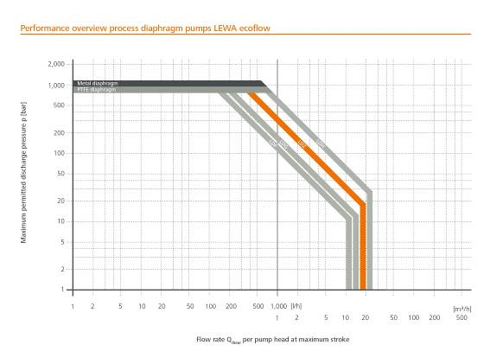
Image-ID: Perfomrance overview.LDZ.jpg
Caption: The new drive unit model, LDZ, which is designed for a hydraulic output of 15 kW, is intended to close the gap between the LDG (6 kW) and the LDH (20 kW) sizes. Just like the other models in the series, it can be used as a single or multiplex drive unit and, thanks to its modular system, can be tailored to the customer's needs.
Source: LEWA GmbH

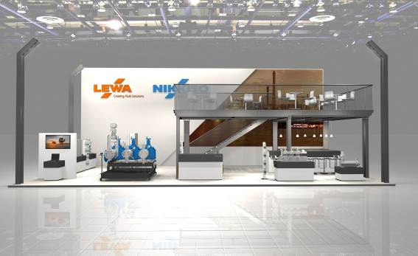
Image ID: ACHEMA-Stand.jpg
Caption: Stefan Glasmeyer, CSO of LEWA, and his team will be available in person to talk anytime during the Achema trade show from June 11 to 15, 2018.
Source: LEWA GmbH

More information for readers/viewers/interested parties:

LEWA GmbH
Ulmer Strasse 10, 71229 Leonberg, Germany
Phone: +49 7152 14-0, Fax: +49 7152 14-1303
E-mail: lewa@lewa.de
Internet: www.lewa.de

Publication free of charge when citing the source, specimen copy requested

