New face at the head of management: Tsunehisa Suita has been managing LEWA Group together with Stefan Glasmeyer and Dr. Martin Fiedler since September 1, 2018

Since September 1, 2018, a three-person group has been managing LEWA Group, a major pump and system manufacturer headquartered in Leonberg in the German state of Baden-Wuerttemberg. The previous CEO, Peter Wagner, is transferring to the American corporate group Cryogenic Industries, which became part of LEWA's parent company NIKKISO Co., Ltd. in August of 2017. In that position, he will be assisted by Hisanao Amino, who previously served as Wagner's Chief Financial Officer in Germany.

Tsunehisa Suita is stepping in for Wagner and Amino in Leonberg. At 58 years old, Suita has thirty years of experience on the international corporate scene and his educational achievements as an economist include earning an MBA from the University of Washington. He has held several key positions at NIKKISO Co., Ltd. since 2010, first as Director and Senior Executive Manager and then as General Manager of the Medical Division and the Corporate Planning Division. He views the work in Leonberg as a welcome challenge and he plans to further bolster the company's growth trend.

Suita completes the new management team of the LEWA Group, which has included Stefan Glasmeyer (CSO) and Dr. Martin Fiedler (COO) since the beginning of 2013. Responsibility in the LEWA Group’s Executive Management for Sales & Marketing and Operations, respectively, remains unchanged for both of them.

LEWA GmbH was founded as a family company by Herbert Ott and Rudolf Schestag in 1952. Today it is the world's leading manufacturer of metering pumps and process diaphragm pumps as well as complete metering packages for process engineering. The Leonberg, Germany-based company developed into an international Group within a few decades and saw further improvement in its position on the world market as part of integration into the Japanese Nikkiso Co. Ltd. in 2009. As a research and production-oriented company, LEWA develops technologies and provides solutions for the vast array of applications among its customers. Its products are used mainly in the oil and gas industry, in gas odorization, in refineries and petrochemicals, as well as in the production of plastics, detergents and cleaners. Additional application areas include the chemical industry, cosmetics industry, pharmaceuticals and biotechnology, food and beverage industry, and energy utilities. LEWA currently employs around 1,200 people and owns 14 subsidiaries around the world along with having 80 representatives and sales offices in more than 80 countries.

Image material:

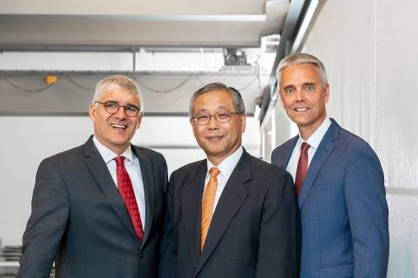
Image ID: LEWA_Management.jpg
Caption: Since September 1, 2018, economist Tsunehisa Suita (centre) has been rounding out the new LEWA Group management team, which previously consisted of Stefan Glasmeyer (right) and Dr. Martin Fiedler (left) since 2013.
Source: LEWA GmbH

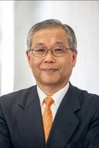
Image ID: Tsunehisa_Suita.jpg
Caption: At 58 years old, Suita has thirty years of experience on the international corporate scene and his educational achievements as an economist include earning an MBA from the University of Washington. He has held several key positions at NIKKISO Co., Ltd. since 2010, first as Director and Senior Executive Manager and then as General Manager of the Medical Division and the Corporate Planning Division. Suita views the work in Leonberg as a welcome new challenge.
Source: LEWA GmbH

More information for readers/viewers/interested parties:

LEWA GmbH
Ulmer Strasse 10, 71229 Leonberg, Germany
Phone: +49 7152 14-0, Fax: +49 7152 14-1303
E-mail: lewa@lewa.de
Internet: www.lewa.de

