Natural gas and crude oil extraction
Chemical Injection Package enables MEG injection for extraordinary requirements on vibrations and noise emissions
Process safety thanks to leakage monitoring by means of radar technology

By Yves Marinoff, Regional Sales Manager at LEWA GmbH

The thirst for the coveted raw product of natural gas remains unquenched, despite the crisis in oil and gas. Each year, the global quantity of drilling platforms increases – their number has gone up by 25 percent in just the last seven years alone. In the course of this, locations in coastal regions or in the vicinity of animal nesting areas have also been developed. As a result, the pressure on manufacturers of platform components to adapt their products to environmental demands is on the rise. These manufacturers must ensure a safe process without disturbances while at the same time providing for the greatest possible protection of people and nature. This requires a departure from standard solutions towards an increasingly flexible product design, one that takes governmental regulations, standards and customer specifications into account—all of which are currently rising greatly in stringency. For this reason, the globally-operating LEWA GmbH relies upon intensive project management and excellently trained engineers for its Chemical Injection Packages, in order to optimize the customized design engineering with regard to factors such as noise emissions and vibrations, as well as the prevention of leaks.

From the date of their discovery in 1811, gas hydrates were overlooked for nearly a hundred years after as having been only a “chemical curiosity” – until gaining relevance at the beginning of the 20th century as the result of ice-like entities causing pipelines to break down. In the meantime, this problem was met with the injection of various substances – what are referred to as inhibitors. Monoethylene glycol (MEG) is among them. This organic compound has the benefit that it is not only suitable for the prevention of hydrate formation, but also for gas drying. Furthermore, MEG can for the most part be reclaimed from the process, thus being capable of being reused. Not only does this help to preserve the environment, it also lowers the necessity of transporting the chemical to drilling platforms.

Tried-and-tested system in customized design variations

Due to the two MEG application options, it can be utilized on an oil rig for two components. For one, it is intermittently injected into the borehole top between the upper main valve and the throttle valve to prevent the formation of hydrates. For another, an injection into the cooler of the gas export compressor for the purpose of gas drying is possible. The process is usually carried out at low flow rates by means of diaphragm pumps – at large quantities by means of plunger pumps – which, are installed with tanks, piping and instrumentation, all the way to integrated Chemical Injection Packages, exemplified by the globally-active LEWA GmbH. Among other advantages, this has the benefit of being able to take the interactions between individual components into account in the course of an overall optimization effort.

Whereas the process planning is the responsibility of the specific engineering company, it is the manufacturer who needs to undertake the detailed engineering in accordance with the tenders. The difficulty here is to bring the often highly complex, necessary standards – for example, in relation to environmental protection and operating safety – into accord with the directives and laws that are applicable at the location of use, as well as with customer specifications. In most cases, engineering solutions must be found which diverge from customary solutions. For this purpose, LEWA employs engineers from various disciplines such as hydraulic systems engineering, mechanical engineering and electrical engineering, who contribute to the evolution with their expertise, thus being able to react with flexibility to the most diverse regional conditions.

Keeping negative influence on the environment at a minimum

Most importantly, the harsh sea environment makes special designs necessary. The extremely salty atmosphere makes the use of corrosion-protected materials essential. This is why LEWA uses materials such as stainless steels for production, in special cases also using duplex or super duplex stainless steels. Owing to the limited space available on an offshore oil rig, it is mandatory that all components such as the pump and fittings are designed to be as compact as possible while simultaneously being conveniently operable.

Furthermore, the system should have as little of a negative influence on life and work quality, as well as on the environment, as possible. This can be achieved by the reduction of noise emissions, which in some circumstances are carried on through structure-borne sound, as well as the reduction of vibrations. One customer desired an especially quiet package. For this purpose, LEWA carried out a corresponding study and searched for possibilities relating to acoustic decoupling. Finally, vibration mats in combination with noise hoods were utilized. As such, sound emission was lowered from 93 dB to 75 dB. In addition, for the minimization of pressure pulsations, the system was submitted to an evaluation in accordance with API 674 Approach 2.

Prevention of leaks

Since MEG is toxic, the highest requirements are placed on process safety and the absence of faults when handling the substance. For this reason, diaphragm pumps are especially well-suited. They are hermetically tight and do not tend toward leakage. Occasionally, however, plunger pumps may be required if, for various reasons, diaphragm pumps cannot be employed or in the event of large flow rates. These are only able to be dynamically sealed by means of packings, which is why special precautions need to be taken in such cases to prevent leaks. For example, in having built a system in accordance with the EU Pressure Equipment Directive (DGRL) for one customer in particular, LEWA deployed a special leak monitoring system alongside a leakage pan together with outlet drainage in a Closed Drain System: Since commercially available flow meters reach their limits in quantities that are so relatively small, the manufacturer determined it was better to go with measurement using radar.

A reduction in maintenance effort also contributes to an increase in process safety. This is why LEWA skids are fully-automatic and mechanically redundant, designed for very long operational durations while featuring a fully-monitored leakage system. Moreover, high-quality fittings and instruments provide support. Some of these have self-diagnostic systems available. Thus, work that is necessary is reduced to a minimum.

Due to the wide variety of requirements – both those stipulated by the client and those laid down by law – LEWA relies on detailed planning and administration by its project management department, which, for example, takes over administrative tasks such as the coordination of subcontractors, progress supervision as well as documentation for the oil and gas industry.

For more information visit www.lewa.de

LEWA GmbH was founded as a family company by Herbert Ott and Rudolf Schestag in 1952. Today it is the world's leading manufacturer of metering pumps and process diaphragm pumps as well as complete metering packages for process engineering. The Leonberg, Germany-based company developed into an international Group within a few decades and saw further improvement in its position on the world market as part of integration into the Japanese Nikkiso Co. Ltd. in 2009. As a research and production-oriented company, LEWA develops technologies and provides solutions for the vast array of applications among its customers. Its products are used mainly in the oil and gas industry, in gas odorization, in refineries and petrochemicals, as well as in the production of plastics, detergents and cleaners. Additional application areas include the chemical industry, cosmetics industry, pharmaceuticals and biotechnology, food and beverage industry, and energy utilities. LEWA currently employs around 1,200 people and owns 14 subsidiaries around the world along with having 80 representatives and sales offices in more than 80 countries.

Bildmaterial:

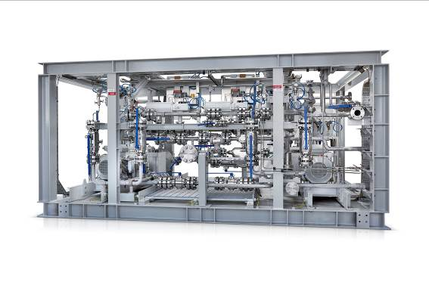
Image ID: Chemical Injection Package1.jpg
Caption: The MEG injection is usually carried out at low flow rates by means of diaphragm pumps, and at large quantities by means of plunger pumps, which LEWA installs with tanks, piping and instrumentation, all the way to integrated Chemical Injection Packages.
Source: LEWA GmbH

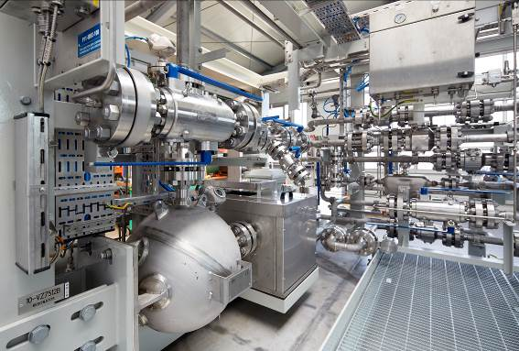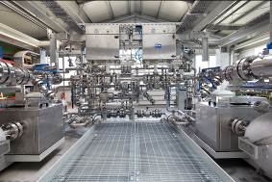
Image ID: Chemical Injection Package2.jpg; Chemical Injection Package3.jpg
Caption: As a result of constricted space conditions, a strict adherence to dimensional specifications is demanded of pump manufacturers such as LEWA.
Source: LEWA GmbH


Image ID: Marinoff.jpg
Caption: “For orders, LEWA relies on detailed planning and administration by its project management department, which, for example, takes over administrative tasks such as the coordination of subcontractors, progress supervision as well as documentation for the oil and gas industry,” says Yves Marinoff, Regional Sales Manager at LEWA GmbH.
Source: LEWA GmbH

More information for readers/viewers/interested parties:

LEWA GmbH
Ulmer Strasse 10, 71229 Leonberg, Germany
Phone: +49 7152 14-0, Fax: +49 7152 14-1303
E-mail: lewa@lewa.de
Internet: www.lewa.de

Publication free of charge when citing the source, specimen copy requested

